- Uploading an object to bucket using gsutil sdk

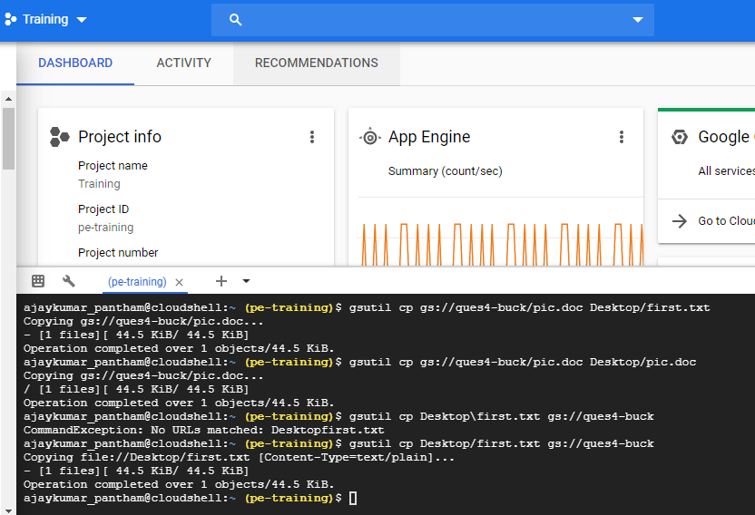

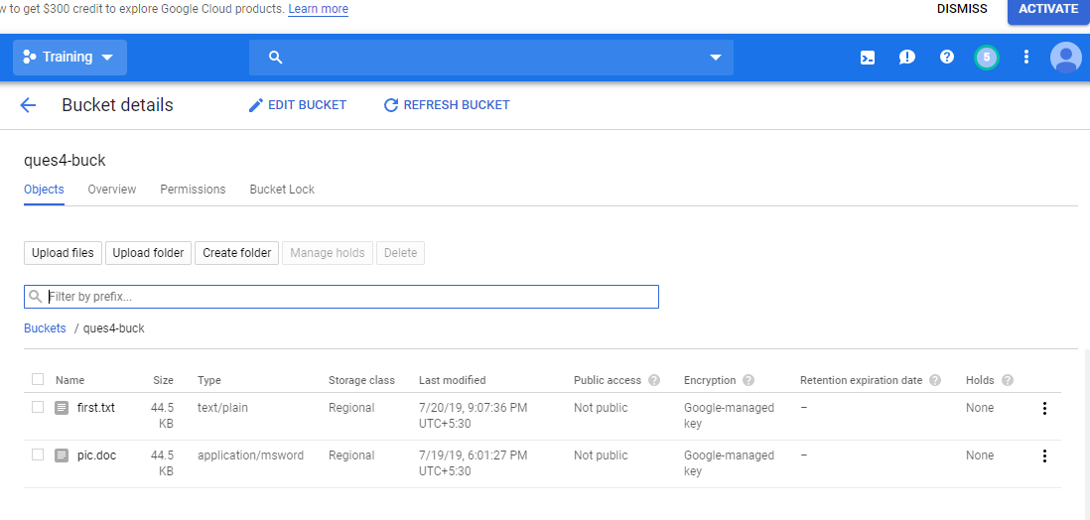

1. Upload
gsutil cp Desktop/first.txt gs://ques4-buck

Copy obj to another folder

gsutil mv gs://ques4-buck/first.txt gs://ques4-buck/first1.txt

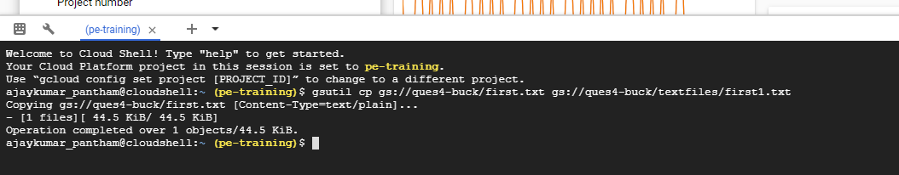

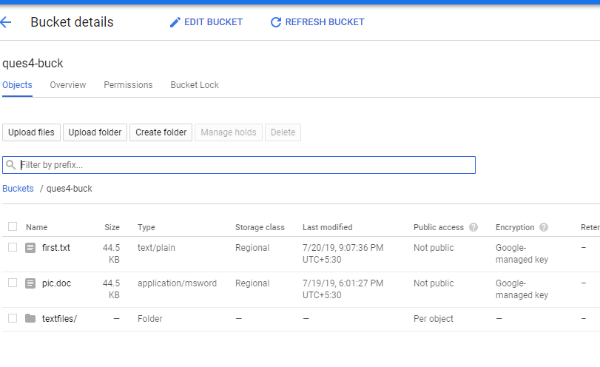

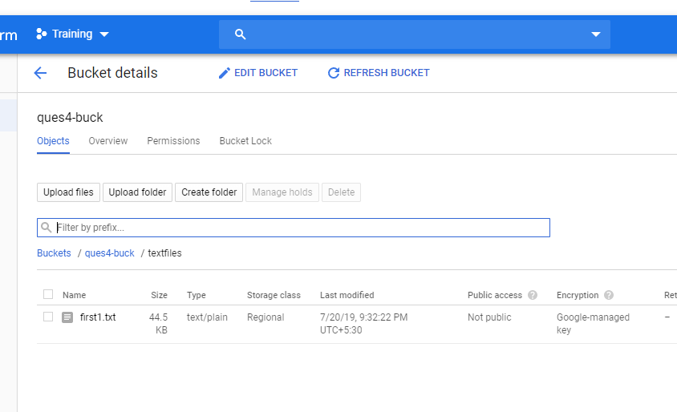

Move

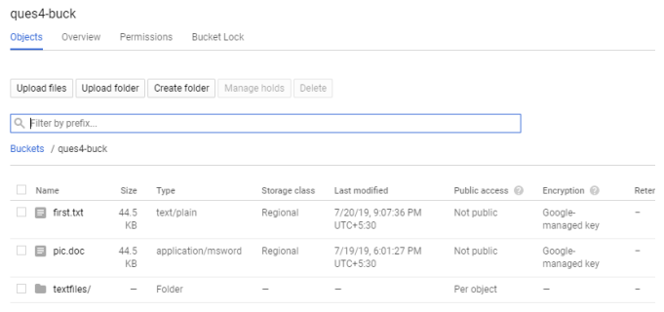

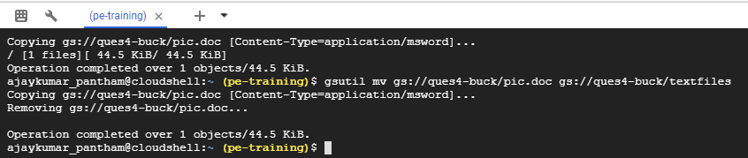

3.Move

gsutil mv gs://ques4-buck/pic.doc gs://ques4-buck/textfiles
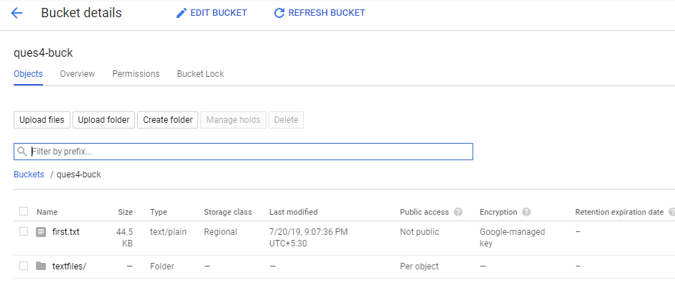
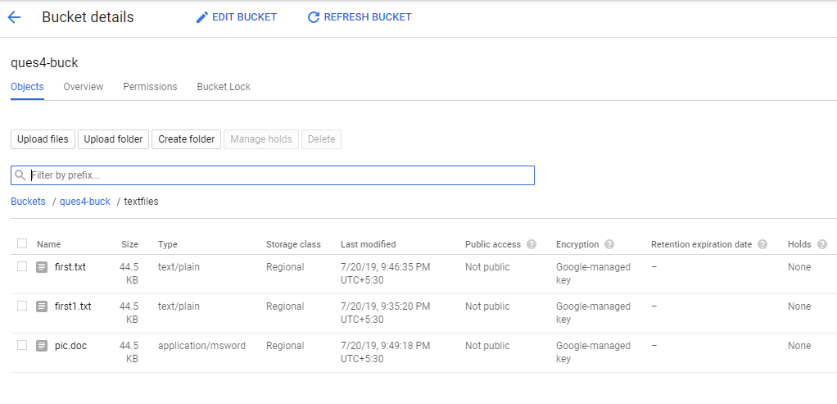

4. Download
gsutil cp gs://ques4-buck/first.txt Desktop

5. Delete
gsutil rm gs://ques4-buck/first1.txt

